Matt Kirsch

Associate Curator

The Noguchi Museum

32-37 Vernon Boulevard

Long Island City, NY 11106

[**mkirsch@noguchi.org**](mailto:mkirsch@noguchi.org)

NOGUCHI, ISAMU (1904 – 1988) Word Count: 492

Searching for a redefinition of sculpture, Isamu Noguchi’s work slipped between object making, industrial design, set design for theatre and dance, public sculpture and land art. Born in Los Angeles, Noguchi was raised in Japan by his American mother while remaining estranged from his Japanese father, and at age thirteen he returned to America for schooling. Noguchi was a promising New York sculptor in the academic Western tradition before a formative experience working as an assistant to the sculptor, Constantin Brancusi, in Paris in 1927, from whom he gained his first understanding of the nature of abstraction as a means of distilling essences. In New York in the 1940s, Noguchi created a series of delicate sculptures in slate and marble (including *Kouros* 1944-45) that stood under the architectural tension of their interlocking elements. Despite growing notoriety, in 1949 Noguchi embarked on a two year excursion throughout Western Europe, India, and Southeast Asia to observe how societies related to secular and ceremonial spaces like temples, plazas and marketplaces. His observations formed the basis for his collaborations with architects on public spaces from the 1950s onward, which recast sculpture in experiential terms.

Throughout his career, Noguchi responded to what he saw as a lack of a human element in pure abstraction. Remaining interested in the human, he used its form and scale as a measure even as his ideas for the scope of sculpture grew. Collaborations with the visionary inventor R. Buckminter Fuller and the choreographer Martha Graham, for whom he designed over twenty dance sets over three decades, deepened his thinking of the relationship of sculpture to the wider world. Concurrent with his studio practice in the 1940s, Noguchi designed a number of mass-produced tables for Knoll and Herman Miller. On his return to Japan in 1950, Noguchi rekindled his appreciation for traditional Japanese materials and ancient folk forms, leading to experiments with ceramic sculpture and his *Akari* light sculptures, highlighting his disregard for distinctions between fine and applied art. He realised his first commissions for outdoor spaces in Japan, leading to later collaborations including the UNESCO garden in Paris (1956- 58) and the Sunken Garden at Beinecke Rare Book and Manuscript Library at Yale University (1960– 64). An ongoing dichotomy of tensions within his work—gravity and weightlessness; nature and technology; East and West; intuition and intellectual engagement—is evident in the symbolic and philosophical values he attributed to the materials he chose for wide-ranging projects. However, it was Noguchi’s enduring interest in stone that motivated his multivalent practice over six decades, culminating in a revelatory final body of work in granite and basalt where, embracing process-art, he practiced increasingly minimal interventions to reveal a profoundly elemental connection to our planet.

**References and further reading**

Apostolos-Capadona, D. and Altshuler B., eds. (1994) *Isamu Noguchi: Essays and Conversations*. New York: Harry Abrams, Inc.

Ashton, D. (1992) *Noguchi East and West*. New York: Alfred A. Knopf.

Noguchi, I. (1968) *A Sculptor’s World*. New York: Harper & Row.

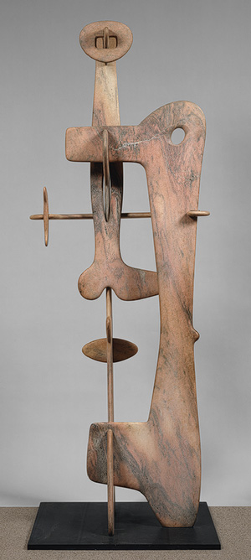http://www.metmuseum.org/toah/art/magnify_sm.gif

*Kouros*, 1944–45, Marble; 117 in. H base: 34 1/8 in. x 42 in. The Metropolitan Museum of Art, New York, Fletcher Fund, 1953 (53.87a–i)

<http://www.metmuseum.org/toah/works-of-art/53.87a-i>

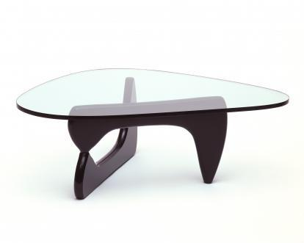

Coffee Table (IN-50), 1944, walnut and glass, produced for Herman Miller

<http://www.noguchi.org/museum/collection/coffee-table-50>

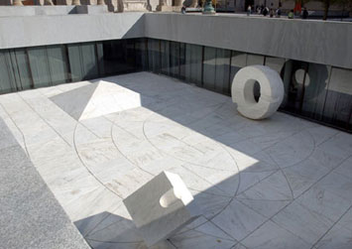

Sunken Courtyard for Beinecke Rare Book and Manuscript Library, Yale University, New Haven, CT

<http://www.yale.edu/publicart/noguchi.html>

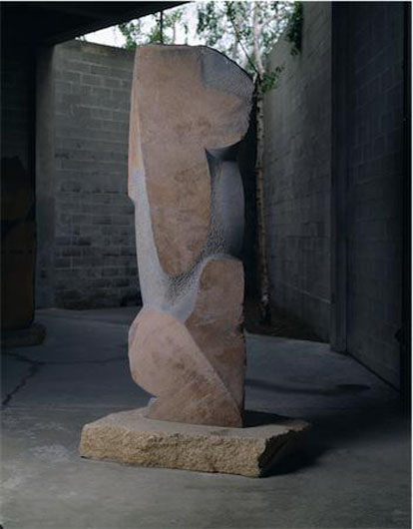

Venus, 1980, Manazuru stone, 94 1/8 x 31 1/4 x 18 7/8 inches, The Noguchi Museum, New York

http://www.noguchi.org/museum/collection/venus